# Multiple access protocol/[media access control](https://www.javatpoint.com/mac-full-form)s

# CSMA/CD (Collision Detection): This is an extension of CSMA used in Ethernet networks. In CSMA/CD, devices listen while transmitting to detect collisions. If a collision is detected, the devices involved in the collision wait for a random amount of time before attempting to retransmit.

# CSMA/CA (Collision Avoidance): Unlike CSMA/CD, CSMA/CA is used in wireless networks where collision detection is not feasible. Devices using CSMA/CA attempt to avoid collisions by waiting for random periods before transmitting data.

# Token Passing: In token passing networks, a token is passed sequentially between devices. Only the device holding the token can transmit data. This method ensures fair access to the network and eliminates collisions.

# Polling: In polling, a central controller polls each device in the network in turn, granting permission to transmit data when it's their turn. This method is commonly used in centralized networks but can suffer from inefficiency and delays.

# Switching techniques

In large networks, there can be multiple paths from sender to receiver. The switching technique will decide the best route for data transmission.

Switching technique is used to connect the systems for making one-to-one communication.

**Classification Of Switching Techniques**

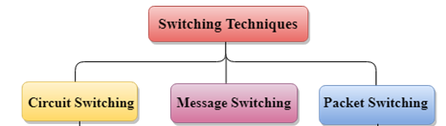

## **Circuit Switching**

* Circuit switching is a switching technique that establishes a dedicated path between sender and receiver.
* In the Circuit Switching Technique, once the connection is established then the dedicated path will remain to exist until the connection is terminated.
* Circuit switching in a network operates in a similar way as the telephone works.
* A complete end-to-end path must exist before the communication takes place.
* In case of circuit switching technique, when any user wants to send the data, voice, video, a request signal is sent to the receiver then the receiver sends back the acknowledgment to ensure the availability of the dedicated path. After receiving the acknowledgment, dedicated path transfers the data.
* Circuit switching is used in public telephone network. It is used for voice transmission.
* Fixed data can be transferred at a time in circuit switching technology.

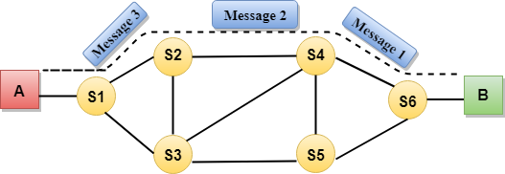

**Advantages Of Circuit Switching:**

* In the case of Circuit Switching technique, the communication channel is dedicated.
* It has fixed bandwidth.

**Disadvantages Of Circuit Switching:**

* Once the dedicated path is established, the only delay occurs in the speed of data transmission.
* It takes a long time to establish a connection approx 10 seconds during which no data can be transmitted.
* It is more expensive than other switching techniques as a dedicated path is required for each connection.
* It is inefficient to use because once the path is established and no data is transferred, then the capacity of the path is wasted.
* In this case, the connection is dedicated therefore no other data can be transferred even if the channel is free.

## **Message Switching**

* Message Switching is a switching technique in which a message is transferred as a complete unit and routed through intermediate nodes at which it is stored and forwarded.
* In Message Switching technique, there is no establishment of a dedicated path between the sender and receiver.
* The destination address is appended to the message. Message Switching provides a dynamic routing as the message is routed through the intermediate nodes based on the information available in the message.
* Message switches are programmed in such a way so that they can provide the most efficient routes.
* Each and every node stores the entire message and then forward it to the next node. This type of network is known as **store and forward network.**
* Message switching treats each message as an independent entity.

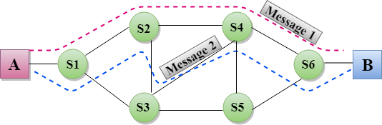

**Advantages Of Message Switching**

* Data channels are shared among the communicating devices that improve the efficiency of using available bandwidth.
* Traffic congestion can be reduced because the message is temporarily stored in the nodes.
* Message priority can be used to manage the network.
* The size of the message which is sent over the network can be varied. Therefore, it supports the data of unlimited size.

**Disadvantages Of Message Switching**

* The message switches must be equipped with sufficient storage to enable them to store the messages until the message is forwarded.
* The Long delay can occur due to the storing and forwarding facility provided by the message switching technique.

## **Packet Switching**

* The packet switching is a switching technique in which the message is sent in one go, but it is divided into smaller pieces, and they are sent individually.
* The message splits into smaller pieces known as packets and packets are given a unique number to identify their order at the receiving end.
* Every packet contains some information in its headers such as source address, destination address and sequence number.
* Packets will travel across the network, taking the shortest path as possible.
* All the packets are reassembled at the receiving end in correct order.
* If any packet is missing or corrupted, then the message will be sent to resend the message.
* If the correct order of the packets is reached, then the acknowledgment message will be sent.

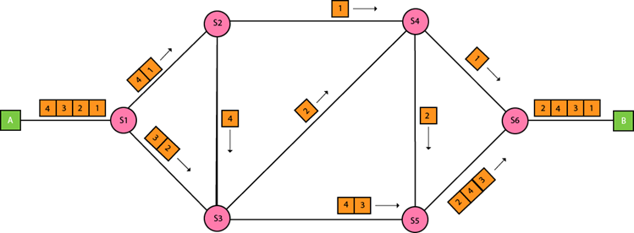

**Advantages Of Packet Switching:**

* **Cost-effective:** In packet switching technique, switching devices do not require massive secondary storage to store the packets, so cost is minimized to some extent. Therefore, we can say that the packet switching technique is a cost-effective technique.
* **Reliable:** If any node is busy, then the packets can be rerouted. This ensures that the Packet Switching technique provides reliable communication.
* **Efficient:** Packet Switching is an efficient technique. It does not require any established path prior to the transmission, and many users can use the same communication channel simultaneously, hence makes use of available bandwidth very efficiently.

**Disadvantages Of Packet Switching:**

Packet Switching technique cannot be implemented in those applications that require low delay and high-quality services.

The protocols used in a packet switching technique are very complex and requires high implementation cost.

If the network is overloaded or corrupted, then it requires retransmission of lost packets. It can also lead to the loss of critical information if errors are nor recovered.

**Ethernet Standards**

* Ethernet protocols describe the rules that control how communication occurs on an Ethernet network.
* **IEEE 802.3** Ethernet standard specifies that a network implement the CSMA/CD access control method.
* In **CSMA/CD** all end stations "listen" to the network wire for clearance to send data. When the end station detects that no other host is transmitting, the end station will attempt to send data. Unfortunately collisions might occur.

**Cabled Ethernet standards**

**10BASE-T**

* The IEEE 802.3 standard defines several physical implementations that support Ethernet. Some of the common implementations are described here.
* 10BASE-T is an Ethernet technology that uses a star topology. 10BASE-T is a popular Ethernet architecture whose features are indicated in its name:
  + The ten (10) represents a speed of 10 Mbps.
  + BASE represents baseband transmission. In baseband transmission, the entire bandwidth of a cable is used for one type of signal.
  + The T represents twisted-pair copper cabling.

Advantages of10BASE-T:

* + Installation of cable is inexpensive compared to fiber-optic installation.
  + Cables are thin, flexible, and easier to install than coaxial cabling.
  + Equipment and cables are easy to upgrade.

Disadvantages of 10BASE-T:

* + The maximum length for a 10BASE-T segment is only 328 ft (100 m).
  + Cables are susceptible to Electromagnetic Interference (EMI).

**100BASE-TX “FastEthernet”**

* The high bandwidth demands of many modern applications, such as live video conferencing and streaming audio, have created a need for higher data-transfer speeds. Many networks require more bandwidth than 10 Mbps Ethernet. 100BASE-TX is much faster than 10BASE-T and has a theoretical bandwidth of 100 Mbps. The "X" indicates that you can use many different types of copper and fiber-optic cabling.
* Advantages of 100BASE-TX:
  + At 100 Mbps, transfer rates of 100BASE-TX are ten times that of 10BASE-T.
  + 100BASE-X uses twisted-pair cabling, which is inexpensive and easy to install.
* Disadvantages of 100BASE-TX:
  + The maximum length for a 100BASE-TX segment is only 328 ft (100 m).
  + Cables are susceptible to Electromagnetic Interference (EMI).

**1000BASE-TX “Gigabit Ethernet”**

1000BASE -T is commonly known as Gigabit Ethernet. Gigabit Ethernet is a LAN architecture.

Advantages of 1000BASE-T:

* + The 1000BASE-T architecture supports data transfer rates of 1 Gbps. At 1 Gbps, it is ten times faster than Fast Ethernet, and 100 times faster than Ethernet. This increased speed makes it possible to implement bandwidth-intensive applications, such as live video.
  + The 1000BASE-T architecture has interoperability with 10BASE-T and 100BASE-TX.

Disadvantages of 1000BASE-T:

* + The maximum length for a 1000BASE-T segment is only 328 ft (100 m).
  + It is susceptible to interference.
  + Gigabit NICs and switches are expensive.
  + Additional equipment is required.

**Wireless Ethernet standards**

* IEEE 802.11 is the standard that specifies connectivity for wireless networks.
* IEEE 802.11, or Wi-Fi (wireless fidelity), refers to the collective group of standards, 802.11 (the original specification), 802.11b, 802.11a, 802.11g, and 802.11n. These protocols specify the frequencies, speeds, and other capabilities of the different Wi-Fi standards.
* **802.11a** - Devices conforming to the 802.11a standard allow WLANs to achieve data rates as high as 54 Mbps. IEEE 802.11a devices operate in the 5 GHz radio frequency range and within a maximum range of 150 feet (45.7 m).
* **802.11b** operates in the 2.4 GHz frequency range with a maximum theoretical data rate of 11 Mbps. These devices operate within a maximum range of 300 feet (91 m).
* **802.11g** provides the same theoretical maximum speed as 802.11a, which is 54 Mbps, but operates in the same 2.4 GHz spectrum as 802.11b. Unlike 802.11a, 802.11g is backward-compatible with 802.11b. 802.11g also has a maximum range of 300 feet (91 m).
* **802.11n** is a newer wireless standard that has a theoretical bandwidth of 540 Mbps and operates in either the 2.4 GHz or 5 GHz frequency range with a maximum range of 984 feet (250 m).